The Proxy Pattern is a structural design pattern that provides a surrogate or placeholder for another object to control access to it. In the clinical system , ,the implementation of a Proxy is justified as a critical security and performance layer that stands between sensitive data entities and the various controllers that request them.

Controlled Access and Security
Medical systems handle highly sensitive data, such as the details found in the MedicalRecord or LaboratoryTest classes. Without a Proxy, any class with a reference to a MedicalRecord could theoretically call its viewing methods. By introducing a Secure Proxy, you create a gatekeeper that implements the same interface as the real record. Before the Proxy forwards a call to the real viewPatientMedicalRecords() method, it can first communicate with the AuthenticationController to verify that the current user has the appropriate "Doctor" or "Administrator" role. This ensures that security logic is centralized and consistent, rather than being scattered across every method in every controller.

Resource Management and Lazy Initialization
Proxies are also invaluable for system performance through Lazy Initialization. Medical records and high-resolution imaging results can be memory-intensive to load. Instead of the MedicalRecordController instantiating a full, data-heavy MedicalRecord object immediately, it can instantiate a lightweight Proxy. The real, resource-heavy object is only created or fetched from the database at the exact moment a method like downloadBackup() or viewLaboratoryResults() is actually invoked. This keeps the system responsive, especially when navigating long lists of patients where only a few records might actually be opened.

Remote Proxy and Persistence
Furthermore, in a distributed clinical environment, the data might reside on a remote server. A Remote Proxy can handle the complexities of network communication—such as connecting to a socket or handling timeouts—while appearing to the rest of the system as a local object. This allows the SystemController to interact with a Backup entity as if it were stored locally, even if it is being retrieved from a secured off-site cloud storage via the BackupController.

Conclusion
Ultimately, the Proxy pattern provides a "protective shield" around the system's core data. It allows you to add essential functionality—like permission checks, logging, and smart loading—without modifying the existing entity classes or bloating the business logic in your controllers.\
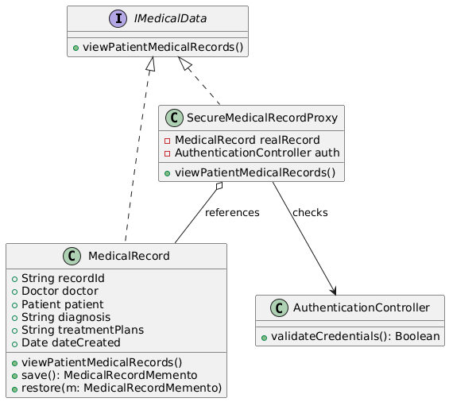

Observer Pattern
The Observer Pattern is a behavioral design pattern that defines a one-to-many dependency between objects so that when one object changes state, all its dependents are notified automatically. In the clinical management system shown in your architecture, introducing this pattern to handle notifications is justified by the critical need for loose coupling, event-driven scalability, and asynchronous communication across diverse hospital departments.

Eliminating Tight Coupling and Direct Dependencies
In a complex medical system, events happening in one department almost always trigger reactions in another. For example, when a LaboratoryController processes a lab sample via processTest(), multiple parties need to know immediately: the ordering Doctor needs to review the results, and the Patient needs an alert to view their updated records.
Without the Observer pattern, the LaboratoryController would have to hold direct, hardcoded references to the Doctor and Patient classes, explicitly invoking their individual update methods. This creates a highly coupled system where changes to how a patient receives alerts would break or require rewriting the laboratory module. By introducing the NotificationManager (the Subject) and the NotificationListener interface (the Observer), the laboratory remains completely oblivious to who is listening. It simply broadcasts that a test is ready, and the manager handles the distribution.

Supporting Dynamic and Flexible Subscriptions
A major challenge in healthcare workflows is that notification requirements change depending on the scenario. For instance, an critical or urgent lab result might require a Nurse or an Administrator to be alerted alongside the primary physician.
Because the NotificationManager maintains a dynamic List<NotificationListener>, the system can add or remove subscribers on the fly using subscribe() and unsubscribe(). If a patient updates their settings to opt into SMS alerts, or if an on-duty nurse needs to temporarily monitor a patient's status, they can be dynamically registered as a listener. The LaboratoryController code never has to change to accommodate these evolving workflow business rules.

Scalability and Separation of Concerns
The Observer pattern beautifully enforces the principle of separation of concerns. The primary responsibility of the LaboratoryController is to handle clinical testing data—not to manage communication infrastructure. Decoupling notification logic ensures that if the hospital later decides to replace basic string messages with an external email service, a push notification server, or an SMS gateway, the changes are isolated strictly within the concrete implementations of the NotificationListener interface.

Conclusion
Ultimately, the Observer pattern transforms a rigid, pull-based system into a reactive, event-driven architecture. It provides a reliable message-delivery pipeline that keeps doctors, patients, and staff informed in real-time, drastically reducing the risk of critical medical data sitting unreviewed due to communication silos.
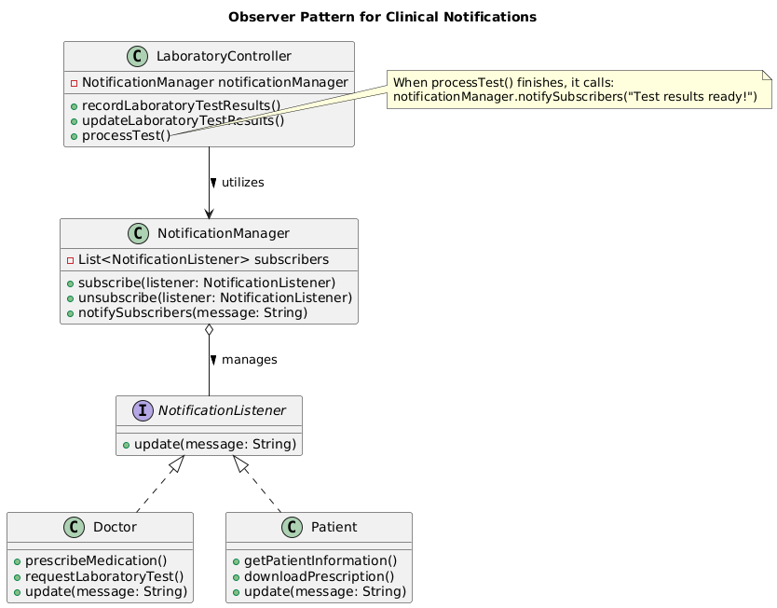
State Pattern
The State Pattern is a behavioral design pattern that allows an object to alter its behavior when its internal state changes, making the object appear as if it changed its class. In the clinical management system shown in your architecture, introducing this pattern to govern the Appointment entity is justified by the need to eliminate complex conditional branching, safeguard business rules, and streamline workflow transitions.

Eliminating Complex Conditional Branching
An appointment in a hospital setting goes through a highly regulated lifecycle: it moves from Scheduled, to In-Progress, to Completed, or potentially Cancelled. Without the State pattern, the system's business rules would have to be checked using sprawling if/else or switch statements across multiple controller methods. For example, a method like rescheduleAppointment() would require nested checks to ensure the appointment isn't already completed or cancelled. As new states are introduced (such as Delayed or No-Show), this conditional logic becomes messy, fragile, and difficult to test. The State pattern sweeps this away by isolating state-specific behaviors into dedicated classes (ScheduledState, InProgressState, CompletedState), ensuring each class only handles the logic relevant to its specific phase.

Safeguarding Lifecycle Business Rules
In medical software, executing an invalid state transition can lead to critical data corruption or scheduling errors—such as accidentally canceling a surgery that is already in progress. The State pattern inherently acts as a defensive guardrail. Because the Appointment class delegates actions directly to its currentState object, illegal operations are blocked at the architectural level. If the AppointmentController attempts to trigger a cancellation while the appointment is in the CompletedState, the state object itself handles the request by throwing an error or safely blocking the action, completely preventing invalid state bypasses.

Enhancing Maintainability and Open-Closed Principle
The State pattern beautifully satisfies the Open-Closed Principle (software entities should be open for extension, but closed for modification). If the clinic decides to add a new operational state, such as a Checked-In state where the patient is waiting in the lobby, developers do not need to modify the core Appointment entity or rewrite the AppointmentController. Instead, they simply create a new concrete class implementing the AppointmentState interface and wire up the transition. The rest of the system remains entirely untouched and unaffected.

Conclusion
Ultimately, the State pattern transforms the Appointment entity from a passive data record with a text status into a dynamic, self-governing state machine. It keeps your controllers thin and focused on coordination, while ensuring that the critical, fluctuating rules of clinical scheduling are cleanly managed, robustly enforced, and easy to scale.
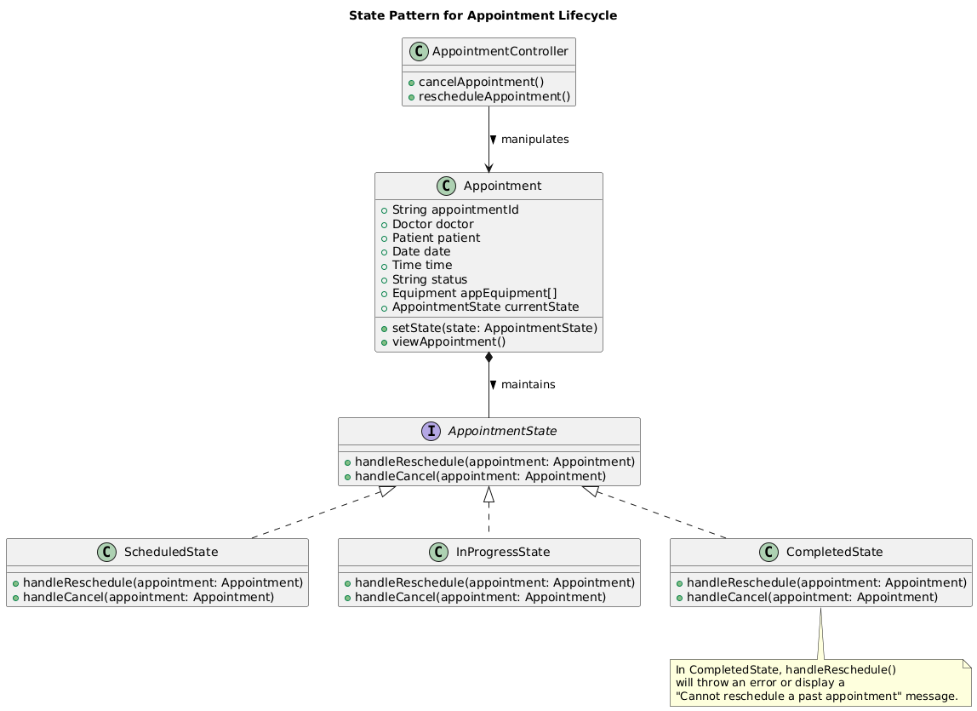

Facade Pattern
The Facade Pattern is a structural design pattern that provides a unified interface to a set of interfaces in a subsystem. It defines a higher-level interface that makes the subsystem easier to use. In the clinical management system shown in your architecture, the implementation of a Facade is justified to simplify interactions with the multitude of specialized controllers and reduce coupling in the overall system architecture.

Simplifying Interactions with Complex Subsystems
The system includes several controllers such as MedicalRecordController, AppointmentController, LaboratoryController, BackupController, and AuthenticationController. A client or higher-level SystemController would otherwise need to manage direct dependencies and the coordination logic between these components. By introducing a ClinicalSystemFacade, high-level operations like "admitPatientAndScheduleTests()" or "processEmergencyAppointment()" can be implemented as single method calls that internally handle the orchestration of the appropriate controllers and entities. This shields the rest of the application from the complexities of the underlying subsystems.

Promoting Loose Coupling and Ease of Use
The Facade pattern adheres to the principle of loose coupling by ensuring that changes in the internal implementation of any controller do not propagate to the calling code. It also makes the system more approachable for new developers or when integrating with the user interface layer. Furthermore, it centralizes common sequences of operations, reducing code duplication across different parts of the application.

Conclusion
Ultimately, the Facade pattern serves as an elegant entry point to the clinical management system’s core functionalities. It allows the system to remain modular and maintainable while providing a clean, simple interface for performing complex clinical workflows.
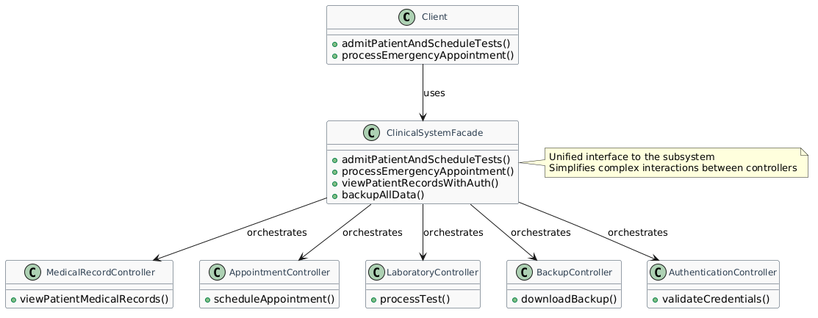

Strategy Pattern
The Strategy Pattern is a behavioral design pattern that defines a family of algorithms, encapsulates each one, and makes them interchangeable within the context. In the clinical management system, this pattern is justified for handling variable behaviors in processes such as appointment scheduling, report generation, or laboratory test processing, allowing flexibility without altering core classes.

Encapsulating Interchangeable Algorithms
For instance, the AppointmentController may need to support different scheduling algorithms depending on hospital policies (e.g., standard FIFO scheduling vs. priority-based for urgent cases vs. resource-availability optimized). Rather than embedding multiple if-else conditions, the system can define a SchedulingStrategy interface with a method like "scheduleAppointment()". Concrete strategies such as FIFOStrategy, PriorityStrategy, and OptimizedStrategy implement this interface. The Appointment class or controller maintains a reference to the current strategy and delegates the scheduling decision to it.

Flexibility and Adherence to Open/Closed Principle
This design allows switching strategies at runtime, for example, activating the priority strategy during high-demand periods, without modifying the AppointmentController or Appointment entity. New strategies can be added seamlessly by creating additional concrete classes, making the system extensible in response to evolving clinical requirements or regulatory changes. This also improves testability, as each strategy can be unit-tested independently.

Conclusion
Ultimately, the Strategy pattern transforms rigid, monolithic logic into flexible, interchangeable components. It ensures that the clinical management system can adapt quickly to different operational needs while keeping the core business logic clean and focused.
